**Laboratory Report   
DeVry University  
College of Engineering and Information Sciences**

**Course Number: DBM405A**

**Professor: Lively**

**Laboratory Number:** 4

**Laboratory Title:** Tables and Indexes

**Submittal Date:** 5/28/2015

Note: There is no limit on how much information you will enter under the three topics below. It is important to be clear and complete with your comments. Like a scientist, you are documenting your progress in this week’s lab experiment.

**Objectives:** In your own words, what was this lab designed to accomplish? What was its purpose?

The main objective/purpose of this lab was to get us acclimated with creating and using indexes from within our tables. In addition, we retouched on some previous topics and got more practice with concepts such as creating tables from the structure of other tables, and then also filling that copied table with the same data as well. A “new” concept was also introduced in this lab as well in the form of changing the structure of these tables (in addition to copying the structures). In addition to all these statements and concepts, we deleted and renamed tables, which was a little bit of review from previous courses as well. Essentially we copied the structure of a previous table, copied its data, changed the structure of it, and then deleted the starting table whilst renaming one of the new ones in its stead.

**Results:** Discuss the steps you used to complete your lab. Were you successful? What did you learn? What were the results? Explain what you did to accomplish each step. You can include screen shots, code listings, etc. to clearly explain what you did.

Please see the following code/screenshots with comment annotation for each number/step of the lab to see how each step was successfully achieved. Please note each highlighted step, and its ensuing successful output:

#1

create table NextSeason as select * from Season where 1=2;

insert into NextSeason

select * from Season;

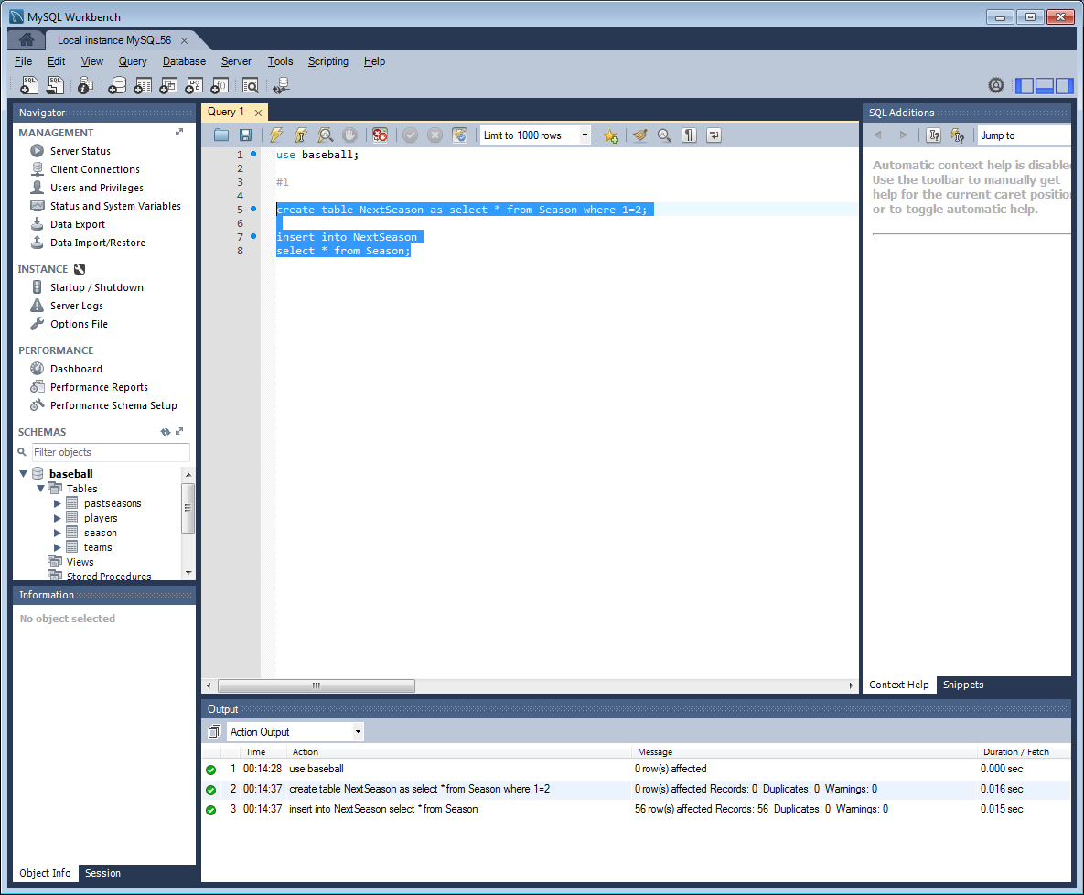

#2

ALTER TABLE `baseball`.`nextseason`

ADD COLUMN `Innings` INT NULL AFTER `AwayTeamScore`;

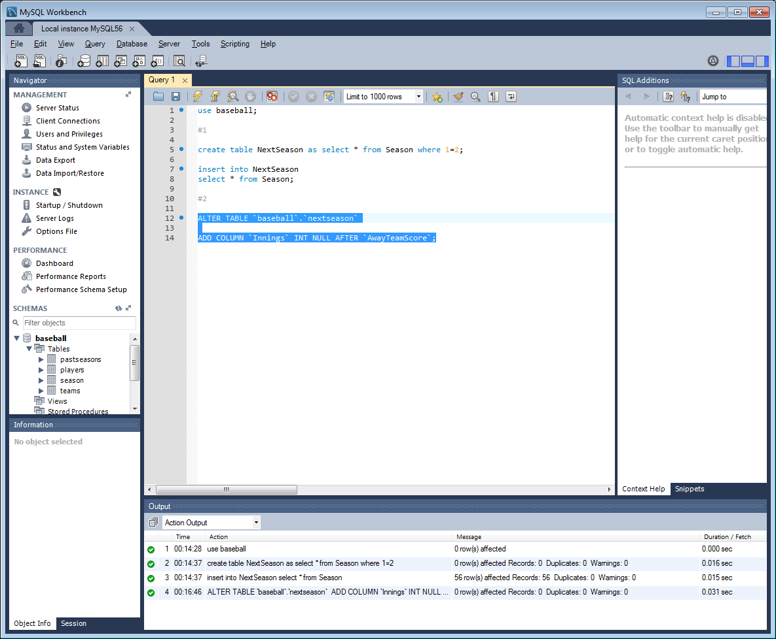

#3

ALTER TABLE `baseball`.`pastseasons`

ADD COLUMN `Innings` INT NULL AFTER `AwayTeamScore`;

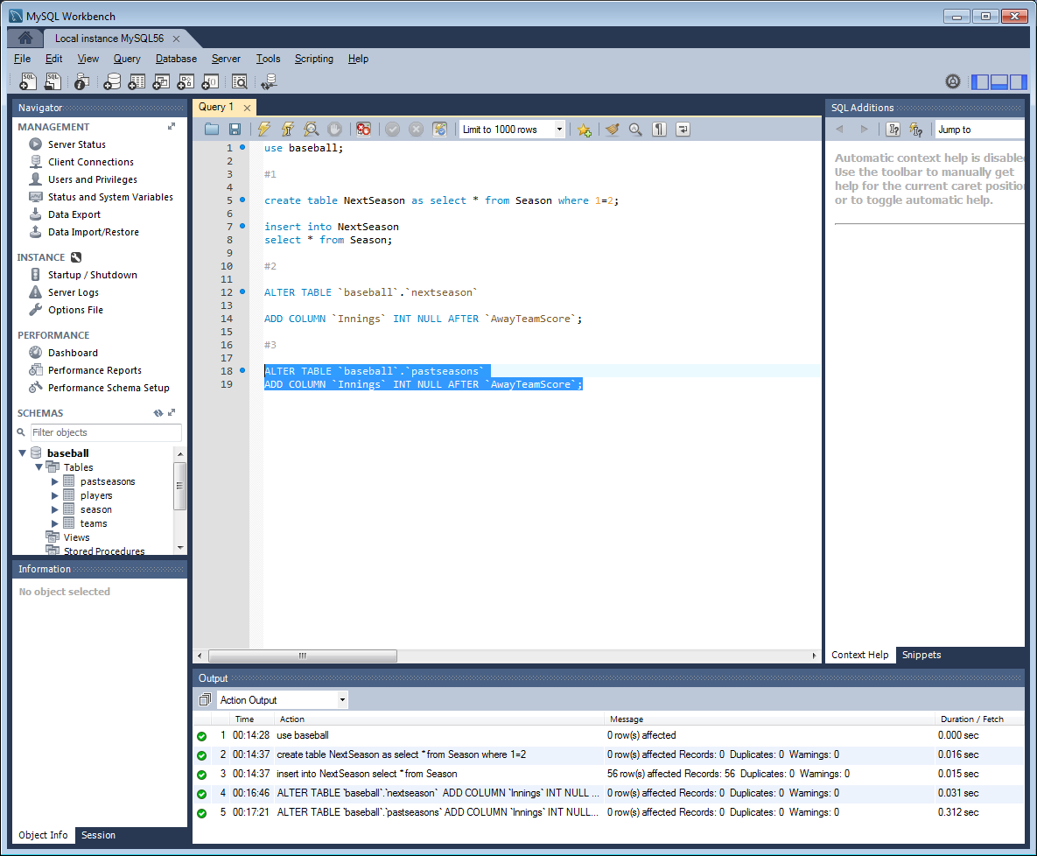

#4

drop table `baseball`.`season`;

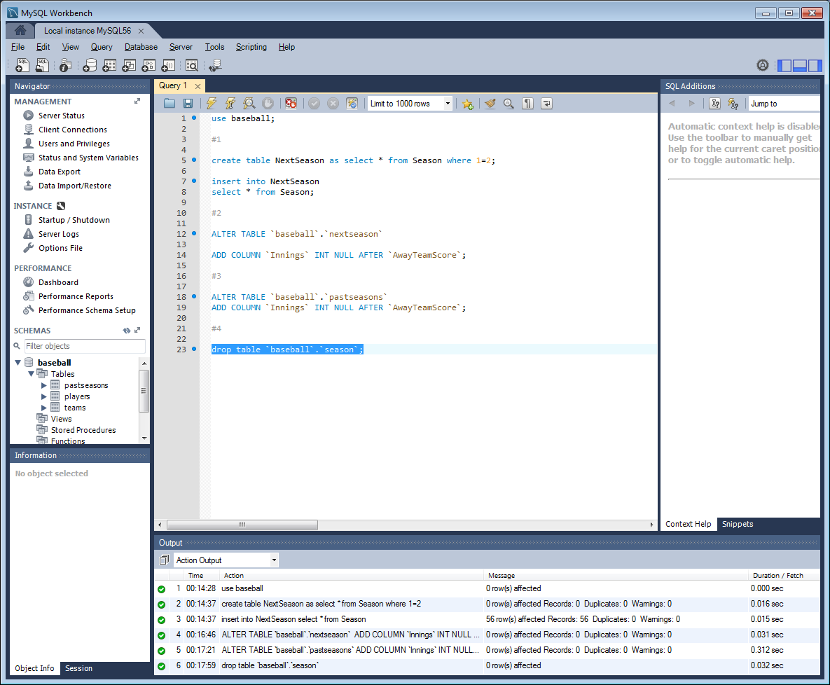

#5

alter table `baseball`.`NextSeason` rename to `Season`;

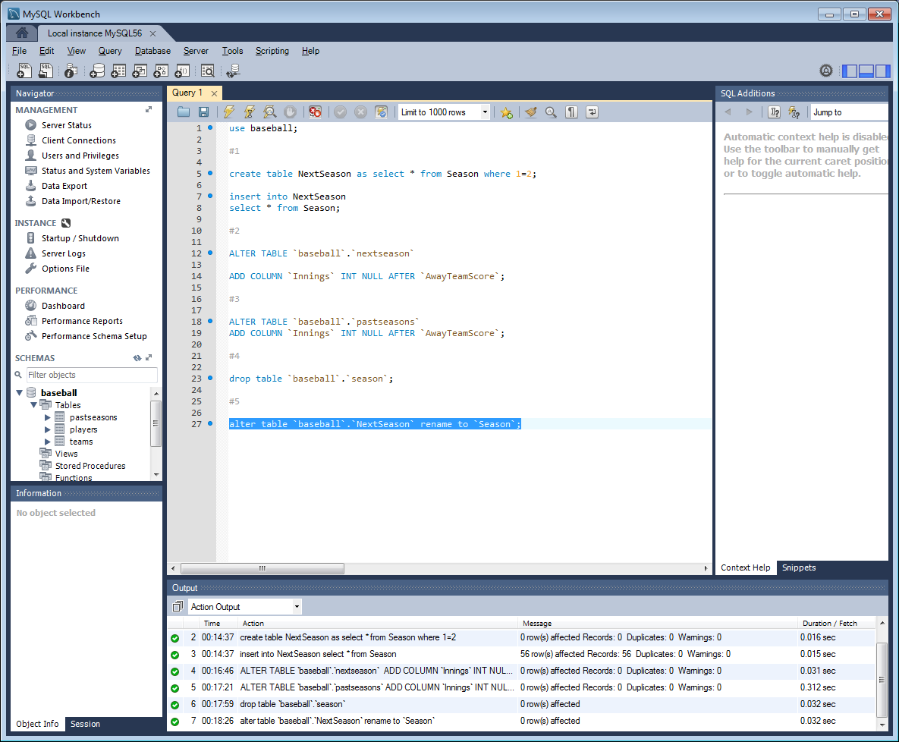

#6

ALTER TABLE `baseball`.`teams`

ADD INDEX `idx_TeamCode` (`TeamCode` ASC);

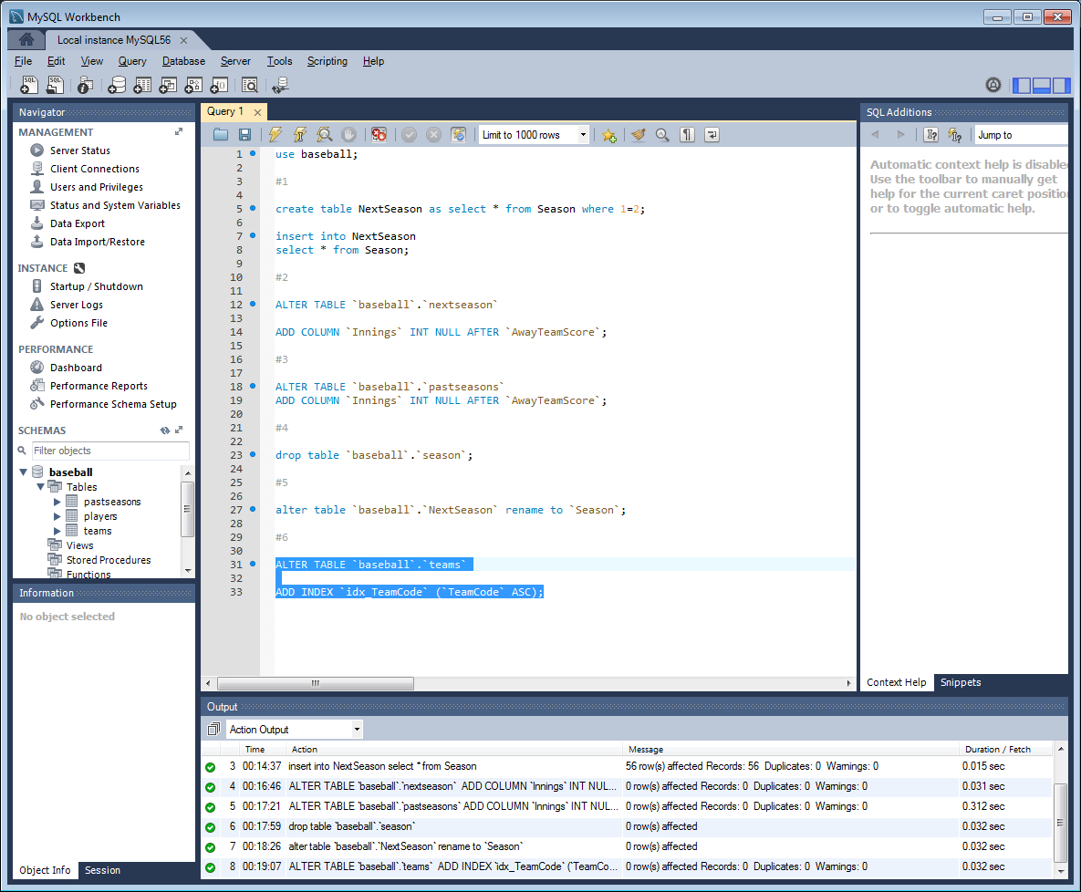

#7

ALTER TABLE `baseball`.`players`

ADD INDEX `idx_Team` (`Team` ASC);

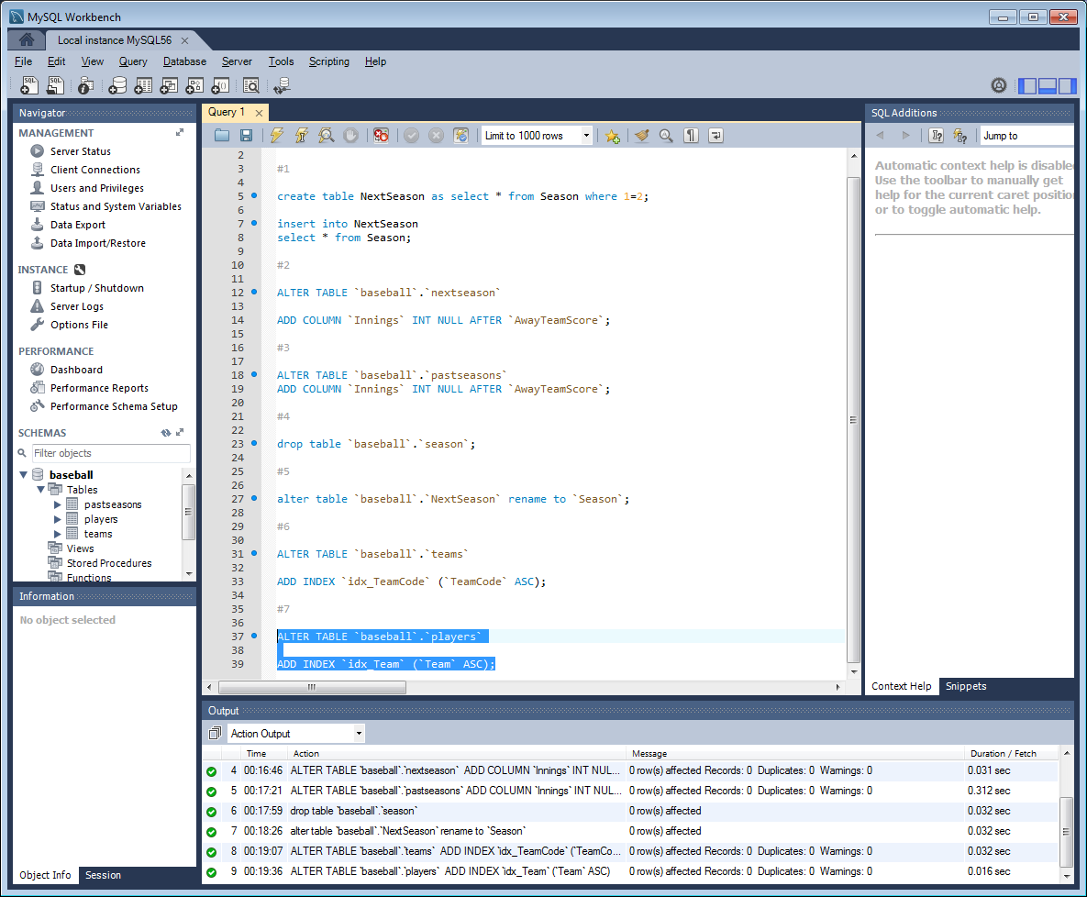

#8

select t.teamcode, p.firstname, p.lastname

from

(select teamcode from baseball.teams) t,

(select team, firstname, lastname from baseball.players) p

where t.teamcode = p.team;

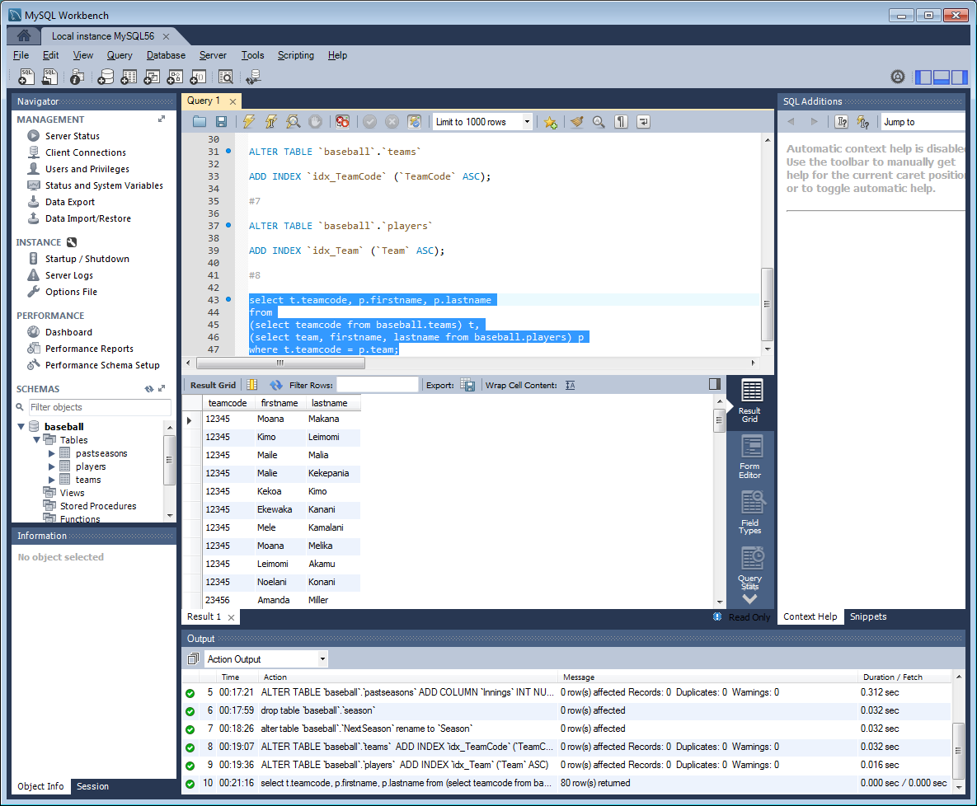

**Conclusions:** After completing this lab, in your own words, what conclusions can you draw from this experience?

Some of the conclusions I can draw from this lab, reiterating from what the objectives/purpose of the lab was, is that quickly creating tables by copying structures and data is a very efficient way to essentially set the groundwork for many more tables once you have created the initial table. Of course this is based on requirements and scope, but the ability to alter the copied tables by adding new columns (changing the structure) as well as rename allows you to cater the created tables more specifically for your needs, again without having to create all tables from scratch. Simple concepts like renaming, deleting and ultimately changing structure allows you to impose as many tables as you need from the creation of just one. Practicing indexing was a completely new concept, but helpful in that it allows you specify what the relevant information is; by doing so you change the focus of the where clause in your query rather than the select. This is efficient and saves resources as well.

|  |  |  |  |  |  |
| --- | --- | --- | --- | --- | --- |
| **Student:** | Anthony Meunier |  | CIS |  | Anthony Meunier |
|  | Name |  | Program |  | Signature |